**SMART STAR EXAMINATIONS BOARD**

**END OF TERM ONE EXAMINATION - 2024**

**ENGLISH**

**TOP CLASS**

My name is…………………………………………

1. **Fill in the missing letter sound**.

a ,b ____,d____, ___

g ____, _____ j

1. **Read and draw.**

stool _________ hoe __________

axe __________ cup ___________

spoon ________ fork __________

1. **Underline for the picture.**

|  |  |
| --- | --- |
|  | broom bag bed |
|  | pin pen pig |
| C:\Users\Head teacher\Pictures\chair.jpg | cat car chair |
|  | book bat balloon |
|  | basket ball box |

**4. Match correctly.**

 in

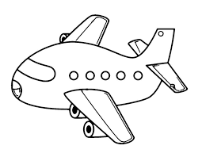

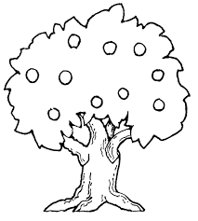 on

over

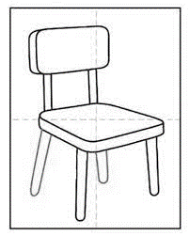

 under

**5. Complete the sentences.**

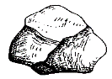 This is a ____________

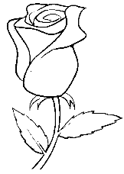 This is a ____________

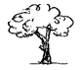This is a ____________

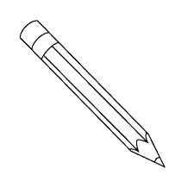D:\IMAGES\girl.pngThis is a ____________

This is a ____________

(tree, stone, girl, flower, pencil)

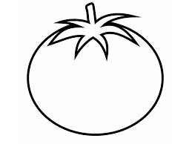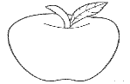**6. Shade the colours.**

**green**

**red**

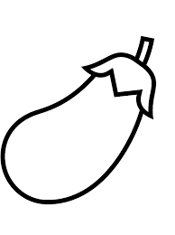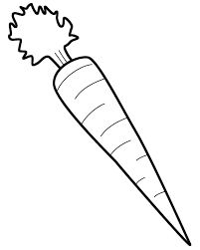

**orange purple**

**7. Name the pictures.**



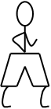



***END.***